**Introduction**

Long checkout lines at the grocery store are one of the biggest complaints about the shopping experience. Soon, these lines could disappear when the ubiquitous [Universal Product Code](http://electronics.howstuffworks.com/gadgets/high-tech-gadgets/upc.htm) (UPC) bar code is replaced by smart labels, also called radio frequency identification (RFID) tags. RFID tags are intelligent bar codes that can talk to a networked system to track every product that you put in your shopping cart.

**Radio-frequency identification (RFID)** is the use of a wireless non-contact system that uses radio-frequency [electromagnetic fields](http://en.wikipedia.org/wiki/Electromagnetic_field) to transfer data from a tag attached to an object, for the purposes of automatic identification and tracking. Some tags require no battery and are powered by the electromagnetic fields used to read them. Others use a local power source and emit [radio](http://en.wikipedia.org/wiki/Radio) waves ([electromagnetic radiation](http://en.wikipedia.org/wiki/Electromagnetic_radiation) at radio frequencies). The tag contains electronically stored information which can be read from up to several meters (yards) away. Unlike a [bar code](http://en.wikipedia.org/wiki/Bar_code), the tag does not need to be within line of sight of the reader and may be embedded in the tracked object.

RFID is an ADC (Automated Data Collection) technology that uses radio-frequency waves to transfer data between a reader and a movable item to identify and categorize. It is fast and does not require physical sight or contact between reader/scanner and the tagged item. It performs the operation using low cost components. Also it attempts to provide unique identification and backend integration that allows for wide range of applications.

**History of RFID**

**Radio frequency identification has been around for decades.** It’s generally said that the roots of [radio frequency identification](http://www.rfidjournal.com/glossary/125) technology can be traced back to World War II. The Germans, Japanese, Americans and British were all using radar—which had been discovered in 1935 by Scottish physicist Sir Robert Alexander Watson-Watt—to warn of approaching planes while they were still miles away. The problem was there was no way to identify which planes belonged to the enemy and which were a country’s own pilots returning from a mission.

Advances in radar and RF communications systems continued through the 1950s and 1960s. Scientists and academics in the United States, Europe and Japan did research and presented papers explaining how RF energy could be used to identify objects remotely. Companies began commercializing anti-theft systems that used radio waves to determine whether an item had been paid for or not. [Electronic article surveillance](http://www.rfidjournal.com/glossary/52) tags, which are still used in packaging today, have a 1-bit tag. The bit is either on or off. If someone pays for the item, the bit is turned off, and a person can leave the store. But if the person doesn't pay and tries to walk out of the store, readers at the door detect the tag and sound an alarm.   
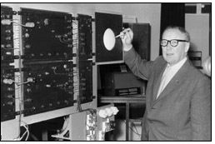

The First RFID Patents

Mario W. Cardullo claims to have received the first U.S. patent for an active [RFID tag](http://www.rfidjournal.com/glossary/137) with rewritable[memory](http://www.rfidjournal.com/glossary/368) on January 23, 1973. That same year, Charles Walton, a California entrepreneur, received a patent for a passive transponder used to unlock a door without a key. A card with an embedded transponder communicated a signal to a [reader](http://www.rfidjournal.com/glossary/129) near the door. When the reader detected a valid identity number stored within the RFID tag, the reader unlocked the door.

**Components of RFID**

**Tags**

Tags are the heart of an RFID system, because they store the information that describes the object being tracked. Specific object information is stored in the memory of tags and is accessed via the radio signal.

Data is transferred between a tag and a reader via low-power radio waves, which are tuned to the same frequency. To obtain information from a tag, a transceiver must send a signal to the RFID tag, causing the tag to transmit its information to the transceiver. The transceiver then reads the signal, converts it to a digital format, and transmits it to a designated application such as an inventory management system.

Tags may be active or passive and read-only, write-once, or read-write. Below is a description of each:

Active tags have a battery, which runs the microchip's circuitry and enables the tags to send a stronger signal to the reader, and have a read range of approximately 100 feet.

Passive tags have no battery. Instead, they draw power from a reader, which sends electromagnetic waves that induce a current in the tag's antenna and powers the microchip's circuits. The chip then modulates the waves the tag sends back to the reader.

Read-only tags contain data, such as a serialized tracking numbers, which are pre-written onto them by the tag manufacturer or distributor. Read-only tags are generally the least expensive, because they cannot have any additional information included as they move throughout the supply chain. Any updates to that information have to be maintained in the application software that tracks the stock unit's movement and activity.

Write-once tags enable a user to write data to the tag one time during production or distribution. This information can be a serial number or other data, such as a lot or batch number.

**Readers and Antennas**

RFID readers are devices that convert radio waves from RFID tags into a form that can be passed to middleware software. An RFID tag reader uses antennas to communicate with the RFID chip.

Reader requirements vary depending on the type of task and application, and almost all applications will require multiple forms of readers to make a successful system.

There are a variety of different reading systems and technologies. These include:

1. Handheld readers that act like a handheld bar code scanner.

2. RFID readers embedded into mobile data collection devices.

3. Fixed readers, which are mounted to read tags automatically as items pass by or near them.

Both middleware and software applications are required in an RFID environment. A major issue for companies seeking to implement an RFID solution is the lack of sufficient middleware to link RFID systems and enterprise applications.

**Middleware**

Software or applications are needed to manage the flow of data from readers and send the data to back-end management systems. RFID middleware assist with the following:

1. Retrieving data from readers.

2. Filtering data feeds to application software.

3. Generating inventory movement notifications.

4. Monitoring tag and reader network performance.

5. Capturing history.

6. Analyzing tag-read events for application tuning and optimization.

**Implementation**

**MATERIALS AND METHODS:**

The product comprises of two very simple gadgets implemented in large numbers viz. RFID tags and RFID readers but the strategy is not so simple as explained below.

RFID tags which associates its unique identification number with a particular user and many sensors for real time validation of multiple readers which come under its umbrella/proximity.

All sensors will be attached to a distributed computing system which will keep logging the events of the users in real – time and providing useful statistics about the rate of accumulation of information of each user.

The Java application developed houses exception handling techniques for failure of a particular system so that redundant systems can take over and provide continued service.

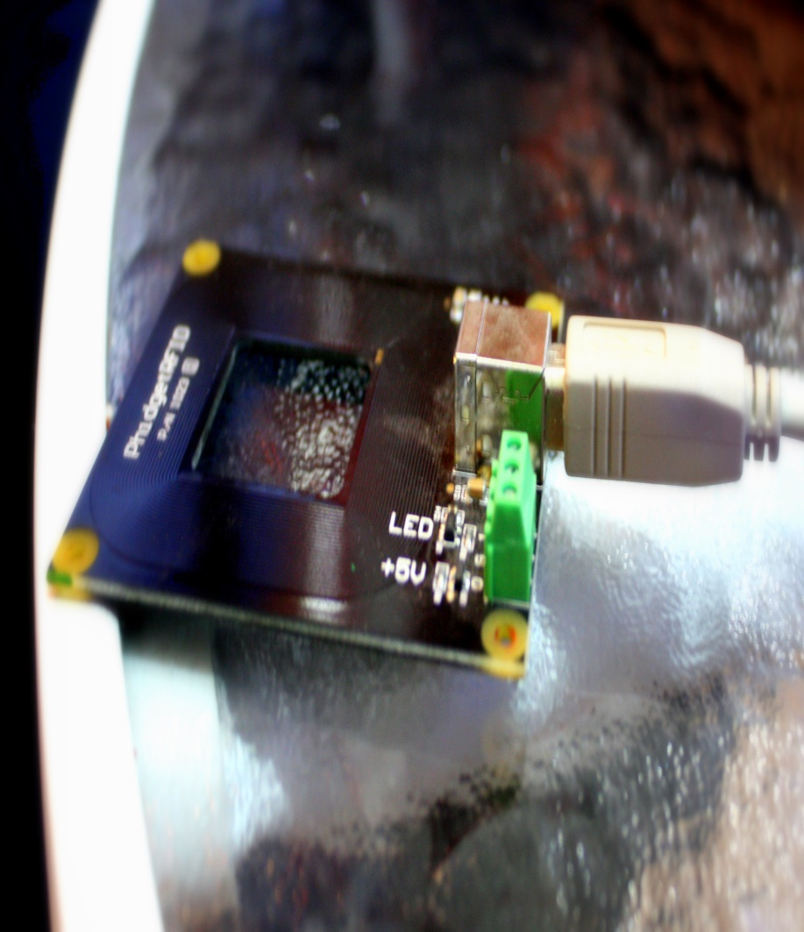

**Algorithm**

The following algorithm describes how an event like generating a text message is done by a RFID system.

RFID (radio frequency identification) systems use data strings stored inside RFID tags or transponders to uniquely identify people or objects when they are scanned by an RFID reader.

In the following case, Phidget RFID Readers(p/n 1023) are used and these identify the RFID tags that are brought in close proximity to the reader and returns the tag identification number using the EM4102 protocol.

The Phidget RFID Reader is connected to the USB interface of a desktop/laptop via which there is a bidirectional exchange of information and commands.

The linking of the reader via the USB port, the activation of the reader and the extraction of the Tag ID is done with the help of the libPhidget Package which is embedded in the user Java program.

Initially the program checks all the USB ports of the system to find the presence of an RFID Reader. The waitForAttachment( ) method is called to wait for the Reader to become available and it blocks up to a certain timeout. Failure of attachment of the device results in an exception being thrown. Upon successful attachment of the device, the Reader is activated and a simple LED helps establish this.

When the antenna detects a new RFID tag in its range,it accesses the data string stored in the RFID tag and along with the Identification ID sends it to the system. At this stage addTagGainListener(TagGainListener ) is called and it adds a tag gained listener. The event is only fired one time for a new tag, so the tag has to be removed and then replaced Parallel to it the antenna of the reader is switched on to detect nearby RFID before another tag gained event will fire. There is no limit on the number of tag gained change handlers that can be registered for a particular Reader.

In this method additional user defined events are executed which sends the Reader serial ID and Tag ID and sends it to the RFID Database. In the Database an appropriate event string is generated on knowing the serial ID of the reader and it assigned to the String to be sent as the text message.

On addition to this the Tag Id detected is compared to the records of the database and on finding the matching user a text message is sent to his mobile device. The message sending is done in addition to a mail being sent to his email ID by way2sms services. Direct message services can be easily implemented by other paid services.

On successfully sending the message the 'Message sent' signal is registered in the database and is actively made visible on the console. Once the current RFID tag moves out of the range of the Reader the addTagLossListener (TagLossListener) method is initialised. It adds a tag lost listener and there is no limit on the number of tag lost change handlers that can be registered for a particular Reader.

In case of any errors in the above processes addErrorListener( ) method is initialized and it adds an error listener. The error handler is a method that will be called when a asynchronous error occurs. Finally an input of '0' is given in the console to shut down the Reader and bring an end to the whole process.

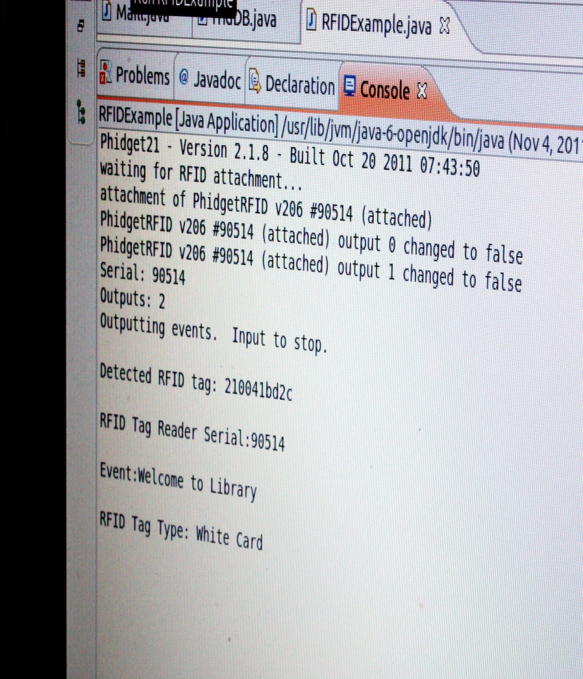

**Applications of RFID**

**Manufacturing**

For today's manufacturer, RFID has become an indispensible tool that lets organizations see their entire process in real-time. Applications built around RFID can help report immediate deviations and exceptions to any process. RFID has allowed companies to build authentication and confirmation into error messages.

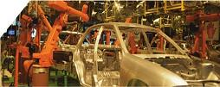

RFID is eliminating costly mistakes resulting in fewer manufacturing errors do to wrong parts used or wrong specification settings. RFID is being used to locate semi-finished goods and eliminate costly delays due to lost or hard to find inventories. RFID works hand in hand with Six Sigma. While Six Sigma seeks to improve the quality of process outputs by identifying and removing the causes of defects, RFID let’s a company identify, time stamp and confirm the location of all measured elements.

This is why manufacturers today look to RFID technology to help them run more efficient operations that help minimize production down time, optimize material and parts inventories, improve and maintain optimal labour output.

GAO RFID can help companies regardless of their requirements. GAO RFID has the broadest selection of technologies. In addition to improving manufacturing performance, RFID is being used to improve safety. RFID is being used to authenticate operators to ensure only properly trained personnel have access to potentially dangerous equipment or sensitive information.

**Benefits include:**

* Real-time tracking of inventory, part kits and sub-assemblies
* Maintains current item information on the tag - ideal for managing production of complex or customized products and assemblies, eliminates the need for separate paperwork on assembly status and content
* Automatically notify the product database when each process is running.

**Retail Industry**

Auto-id has long been used to track and identify parts for car and truck assembly. The vehicle assembly industry realized early on the value of bar codes and recently RFID to ensure the right parts are in stock, ordered just in time and at station when required for the assembly process. Many auto parts are painted and technology was slow to come to these components of the process.

The paint processes for parts manufacturing has always be a challenge when attempting to adopt new technology. Paint and chemicals are always the enemy when using identification markings such as bar codes. Chemicals would remove bar codes and paint would cover them. And then there was the temperature, 215 °C or 419 °F. Along came RFID. RFID was a natural for paint applications. Specially constructed tags can withstand the high temperatures of the ovens and can also withstand the impact of preparatory chemicals. RFID, unlike bar codes do not require line of sight or visual readability. An RFID tag continues to work even when covered with multiple coats of paint. It is no wonder that RFID has moved into the paint shops around the world.

A retail RFID solution requires hardware, tags and readers, and software. The software most retailers would require would validate shipments, transfer product between stores, tracking inventory by store, manage fulfillment operations, manage back room and sales floor movement and tie into existing Point of sales systems. GAO RFID has the industry’s largest selection of tags and readers to choose from and LocateWare™ software that can quickly turn on RFID for a retail operation.

**Tagging Life**

A human **microchip implant** is an integrated circuit device or [RFID](http://en.wikipedia.org/wiki/RFID) transponder encased in silicate glass and implanted in the body of a human being. A [subdermal implant](http://en.wikipedia.org/wiki/Subdermal_implant) typically contains a unique ID number that can be linked to information contained in an external database, such as personal identification, medical history, medications, allergies, and contact information.

### Possible future applications

Theoretically, a GPS-enabled chip could one day make it possible for individuals to be physically located by latitude, longitude, altitude, speed, and direction of movement. Such implantable GPS devices are not technically feasible at this time. However, if widely deployed at some future point, implantable GPS devices could conceivably allow authorities to locate [missing persons](http://en.wikipedia.org/wiki/Missing_person) and/or [fugitives](http://en.wikipedia.org/wiki/Fugitive) and those who fled from a crime scene. Critics contend, however, that the technology could lead to [political repression](http://en.wikipedia.org/wiki/Political_repression) as governments could use implants to track and persecute human rights activists, labor activists, civil dissidents, and political opponents; criminals and domestic abusers could use them to stalk and harass their victims; slaveholders could use them to prevent captives from escaping; and child abusers could use them to locate and abduct children.

**Smart Campus**

The solution lies in making the campus alive and creating a bi-directional communication channel between the student and the campus through RFID thereby supporting each other to have a more environment friendly campus where movement is minimized. In most of the campuses students are given a smart card which contains a micro-chip embedded in it.

The solution would outsmart the smart cards with affordable RFID tags, the latest trend in technology. By using radio frequency identification mobility is enhanced. RFID sensors throughout the campus monitor the activities of students and record it in a database so that the movement to performance gain is optimized.

**Future and Benefits**

Rfid looks at what travel, education and home life will be like when RFID becomes ubiquitous. In all of the future scenarios we paint, most RFID technology described is available today, and the rest is being tested or is currently in development in labs around the world—that is, the applications do not require passive tags that can be [read](http://www.rfidjournal.com/glossary/128) from, say, 10,000 feet away, or active tags that can be read through five feet of lead.   
  
Rfid’s goal in writing these stories was to make vividly plain why we believe radio[frequency](http://www.rfidjournal.com/glossary/76) identification will be ubiquitous in 20 years. You might not want to be on the bleeding edge of RFID adoption today, but some firms are, because they have figured out how to utilize the technology to reduce costs, streamline processes, improve custom service and boost sales. The benefits are real, and there is no turning back.

**Benefits**

* Read/Write

Ability to add information directly to tags enables each unique asset to carry its own unique history

* Non-contact Reads

Ability to read tags at a distance, under a variety of environmental conditions, without physical manipulation of the asset

* Fast Read

- Ability to simultaneously read large numbers (1000-1750 tags/sec) of items

* Automation

- Requires less human intervention

* Authenticity

- Each RFID chip is unique and cannot be replicated

**Conclusion**

RFID technology uses waves to automatically identify individual items. After sixty years of development, the emergence of the Internet, RFID is being used in many fields.  
    
Improvements in standardization have already occurred, with several additional standards under development. The problems with interoperability have mainly been resolved by most large system providers.

Improvements in tag life expectancy and durability have improved substantially in the past few years. There are some hurdles needed to overcome before RFID technology becomes widespread in the world. One major problem is the high costs, the other is privacy issue. 

 In the long run, the RFID technology, when perfected, would eventually be a big help to human.

**Bibliography**

<http://www.rfidjournal.com/>

http://rfidprivacy.com/

http://www.buyrfid.com/

Wiki!